**DAILY ONLINE ACTIVITIES SUMMARY**

|  |  |  |  |  |  |  |  |  |
| --- | --- | --- | --- | --- | --- | --- | --- | --- |
| **Date:** | **09/06/2020** | | | | | **Name:** | **NAIPUNYA VINOD NAIK** | |
| **Sem & Sec** | **IV SEM & A SECTION** | | | | | **USN:** | **4AL18CS050** | |
| **Online Test Summary** | | | | | | | | |
| **Subject** | | **N/A** | | | | | | |
| **Max. Marks** | | **N/A** | | **Score** | | | **N/A** | |
| **Certification Course Summary** | | | | | | | | |
| **Course** | **INTRODUCTION TO PROGRAMMING** | | | | | | | |
| **Certificate Provider** | | | **GREAT LEARNING ACADEMY** | | **Duration** | | | **5.5 HRS** |
| **Coding Challenges** | | | | | | | | |
| **Problem Statement:1)** [Write a C Program to rotate the matrix by K times.](https://github.com/orgs/alvas-education-foundation/teams/2nd-year/discussions/109) | | | | | | | | |
| **Status: EXECUTED** | | | | | | | | |
| **Uploaded the report in Github** | | | | | **YES** | | | |
| **If yes Repository name** | | | | | <https://github.com/naipunya-naik/lockdown-coding/blob/master/C%2B%2B%20CODING/rotate%20matrix_09-06-2020.cpp> | | | |
| **Uploaded the report in slack** | | | | | **YES** | | | |

Online Test Details: (Attach the snapshot and briefly write the report for the same).

NO INTERNALS CONDUCTED

Certification Course Details: (Attach the snapshot and briefly write the report for the same)

CERTIFICATION COURSE NAME:- INTRODUCTION TO PROGRAMMING

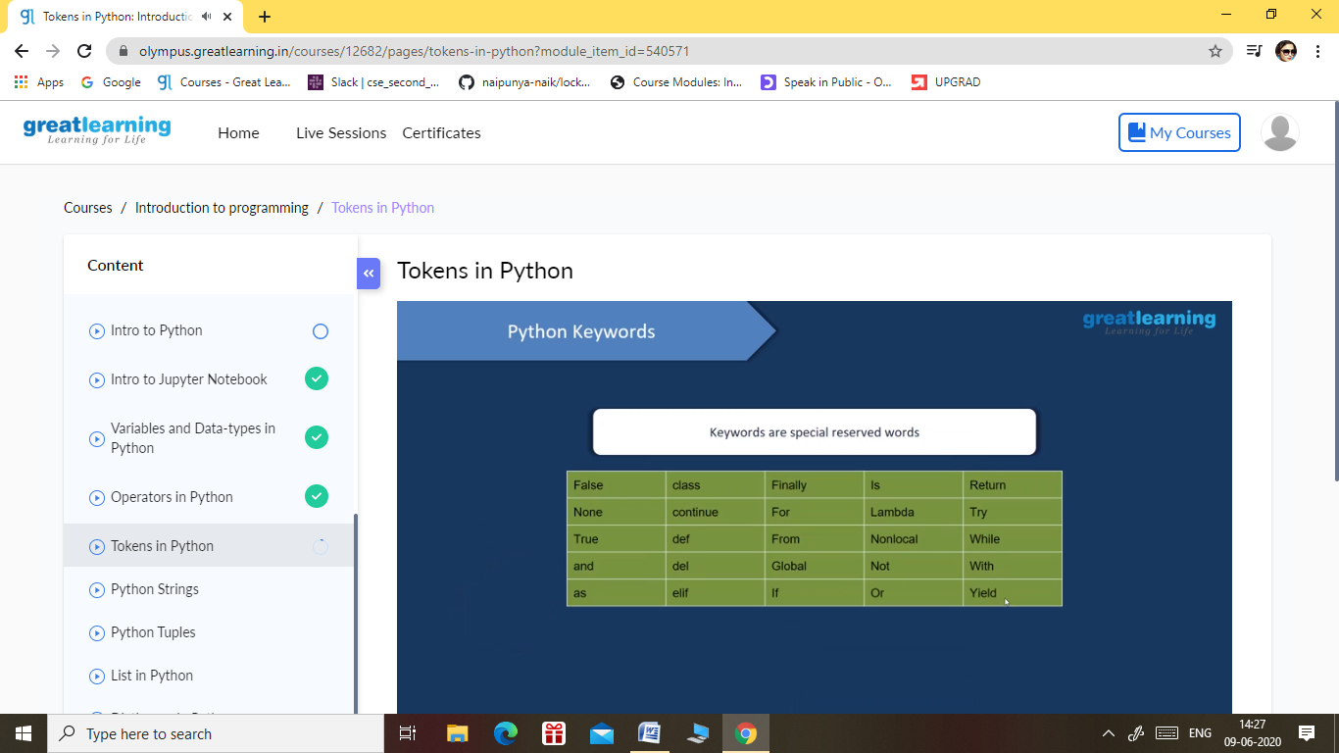

TOPICS LEARNT ON 08 JUNE 2020:-

* Intro to Python
* Intro to Jupyter Notebook
* Variables and Data-types in Python
* Operators in Python
* Tokens in Python

Coding Challenges Details: (Attach the snapshot and briefly write the report for the same).

PROBLEM STATEMENT 1:- [Write a C Program to rotate the matrix by K times.](https://github.com/orgs/alvas-education-foundation/teams/2nd-year/discussions/109)

Rotate the matrix by K times means rotating the given NN matrix to the specified (K) number of times. For example, consider the 33 matrix, which has to be rotated once,  
Enter the Size of the Matrix: 3, 3  
Enter the Elements of the Matrix: 10, 20, 39, 40, 50, 60, 70, 80, 90  
Enter the value of K (Number of Rotations): 1  
Matrix before Rotation:  
10 20 30  
40 50 60  
70 80 90  
Matrix after Rotation:  
20 30 10  
50 60 40  
80 90 70

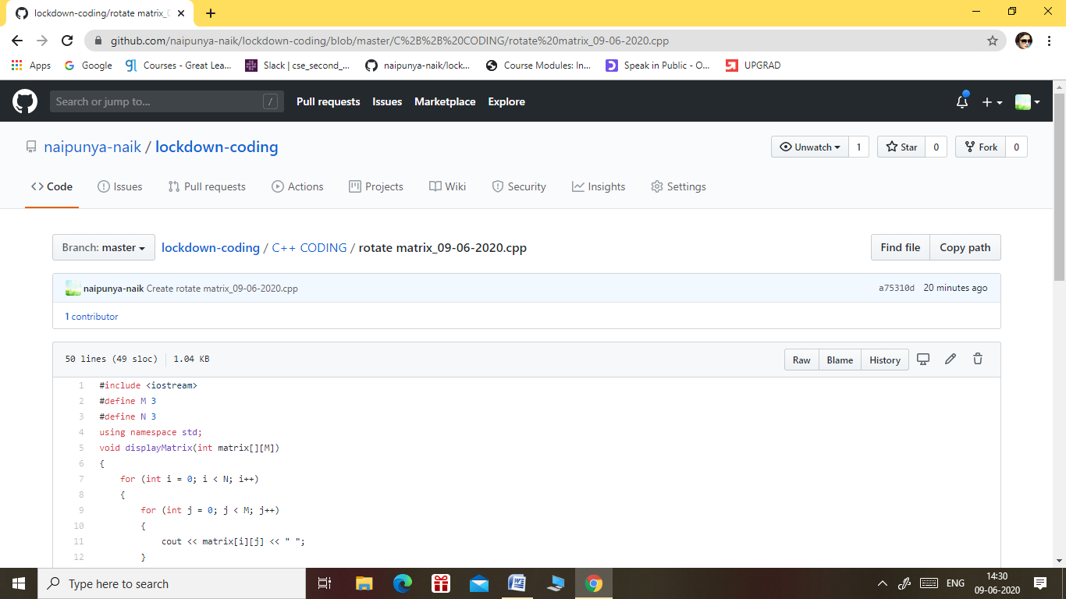

GITHUB REPOSITORY LINK:-

<https://github.com/naipunya-naik/lockdown-coding/blob/master/C%2B%2B%20CODING/rotate%20matrix_09-06-2020.cpp>